**ITS290F Human Computer Interaction & User Experience Design**

**Lab 9. Java Script ES**

What you’ll learn in this lab:

* Java Script ES

**1. Readings**

Suggested reference readings

1. JavaScript ES6: 5 new abstractions to improve your code

<https://blog.logrocket.com/javascript-es6-5-new-abstractions-to-improve-your-code-54a369e82407>

1. ES6 In Depth: Rest parameters and defaults

<https://hacks.mozilla.org/2015/05/es6-in-depth-rest-parameters-and-defaults/>

**2. Lab Exercises**

In this tutorial, we will work on the coding with the ES6 Java scripts (JS). To display intermediate information in a webpage, we used to use an UI element as a medium. This time we will learn to display information on the console window of a web browser. For Google Chrome, we can enable this option with the hotkeys **Ctrl + Shirt + I** (or select **Menu (⁝)** 🡪 **More tools** 🡪 **Developer tools**). Console window is also available on other browsers. You may search for the ways to open it on your own.

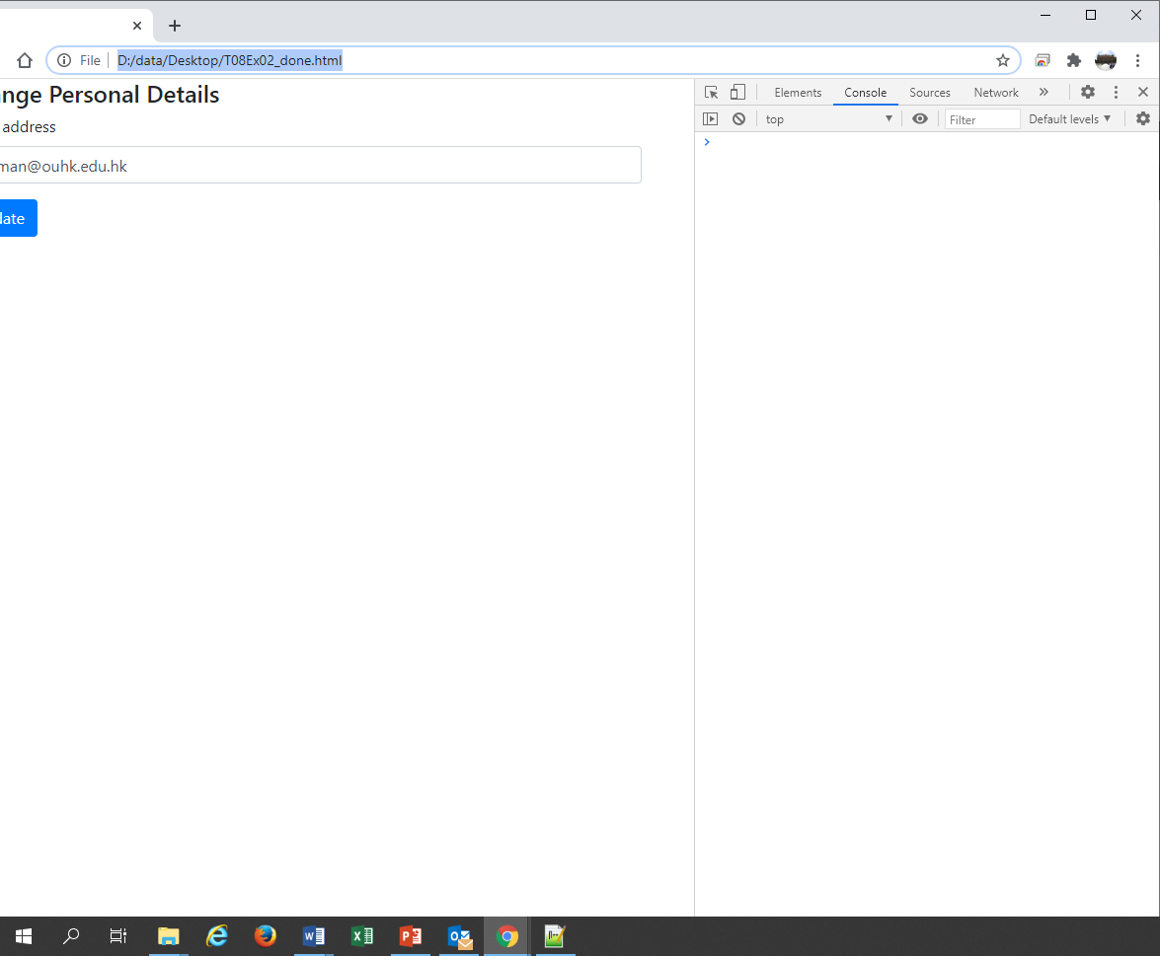

*Console window*

*The console window of Google Chrome*

**Exercise 1**

Open the **T09Ex01.html** file with a text editor and study the code. It has a “Run Script” button on the page, which would trigger the runScript() function when clicked.

Open the page with Google Chrome and open a console window for that page. Click on the “Run Script” button and observe the output on the console window.

|  |
| --- |
| 1. What is the output message displayed on the console window? |
| Hello |

The variable type of greeting1 is declared as a var, where the scope allows the variable can be redeclared inside the if(...) block. Now try to change the two instances of var to let. Save the file and refresh (F5) the page on the browser. Click on the “Run Script” button again and observe the output on the console window.

|  |
| --- |
| 1. What is the output message displayed on the console window? |
| Hey hi |

|  |
| --- |
| 1. According to the trial result of the two different variable types, which of the following statement is true?    1. var can be used to declare constant variables.    2. let can be used to declare global variables.    3. var can be used to declare global variables.    4. let can be used to declare constant variables. |
| c |

**Exercise 2**

Open the **T09Ex02.html** file with a text editor and study the code. There are three constant variables inside the runScript() function, which store the scores of three subjects, i.e. Chinese, English, and Mathematics. It also has an incomplete console.log() statement that intended to print out the average score on the console window.

Complete the console.log() statement so that it can print out the average score with precision of one decimal place. The console output should look like the follows:

The average score is 80.7

Do computation within the console.log() statement and do not change other parts of the script. **Hints**: Refer to the example in page 8 of the L07b lecture slides.

|  |
| --- |
| 1. Submit the completed console.log() statement: |
| console.log(`The average score is ${((chi + eng + math) / 3).toFixed(1)}`); |

Write an arrow function called calculateAverage that accepts the scores of three different subjects as input parameters and returns a string of the average score that the format is similar to the console output in Part A. **Hints**: Refer to the example in pages 9-12 of the L07b lecture slides.

You may add the following statement in the runScript() function to verify the functionality of the calculateAverage arrow function you wrote:

console.log(calculateAverage(chi, eng, math));

|  |
| --- |
| 1. Submit the completed calculateAverage arrow function: |
| const calculateAverage = (chi, eng, math) => {  const average = (chi + eng + math) / 3;  return `The average score is ${average.toFixed(1)}`;  }; |

**Exercise 3**

Open the **T09Ex03.html** file with a text editor and study the code. There is a var array called districts inside the runScript() function, which holds the districts in Hong Kong. It also has a for loop that iterates over the districts and print them out on the console screen one-by-one.

Update the console.log() statement so that it can also print out the number of characters of each district name. The console output should look like the follows:

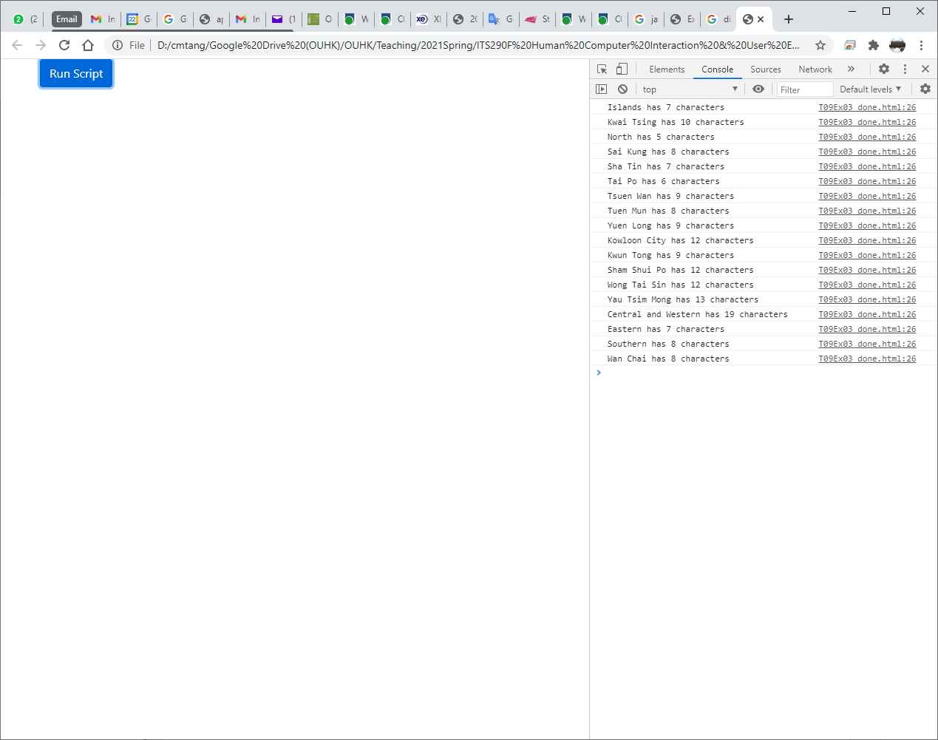

|  |
| --- |
| 1. Submit the completed console.log() statement: |
| console.log(`${d} has ${d.length} characters`); |

**Hints**: Using *object*.length to access the length property of an object.

Add a new arrow function called toUpper to the <script> section as follows:

const toUpper = (x) => {

return x.toUpperCase();

}

This function accepts a string parameter x and converts its value to upper case and then returns. Apply the map() method (refer to lecture slide page 17) that calls the toUpper function to convert all elements in the districts array to upper case and display the result with the console.log() statement in part A. The output should look like to follows:

|  |
| --- |
| 1. Submit the updated runScript() function: |
| function runScript() {  var districts = ["Islands", "Kwai Tsing", "North", "Sai Kung", "Sha Tin", "Tai Po", "Tsuen Wan", "Tuen Mun", "Yuen Long", "Kowloon City", "Kwun Tong", "Sham Shui Po", "Wong Tai Sin", "Yau Tsim Mong", "Central and Western", "Eastern", "Southern", "Wan Chai"];  // Convert districts to uppercase using map  const upperDistricts = districts.map(toUpper);  // Display the results with character counts  for (let d of upperDistricts) {  console.log(`${d} has ${d.length} characters`);  }  } |

|  |
| --- |
| 1. Does your program produce the same output as above illustrated? |
| Yes, the output is same. |

--- End ---